TUGAS PRAKTIKUM 3 PEMEROGRAMAN 1

C:\Users\FAZRIL~1\AppData\Local\Temp\ksohtml\wps_clip_image-4242.png

NAMA : FAZRI RAMADHAN

NIM : 4513210018

PRAKTIKUM 3 PEMEROGRAMAN 1

**KELULUSAN :**

**SOURCECODE**

|  |
| --- |
| public class kelulusan{  public static void main(String[]args){  int nilai=50;  if(nilai>=50){  System.out.println("selamat anda lulus");  }  else  System.out.println("maaf anda tidak lulus");  }  } |

**PRINTSCREEN**

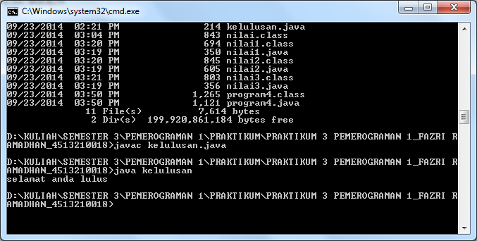

**NILAI 1 :**

**SOURCECODE**

|  |
| --- |
| import java.util.Scanner;  public class nilai1{  public static void main(String[]args){  int nilai;  Scanner masuk = new Scanner(System.in);  System.out.println("Masukkan Nilai :");  nilai = masuk.nextInt();  if(nilai>=50){  System.out.println("Selamat Anda Lulus");  }  else  System.out.println("Maaf Anda Tidak Lulus");  }  } |

**PRINTSCREEN**

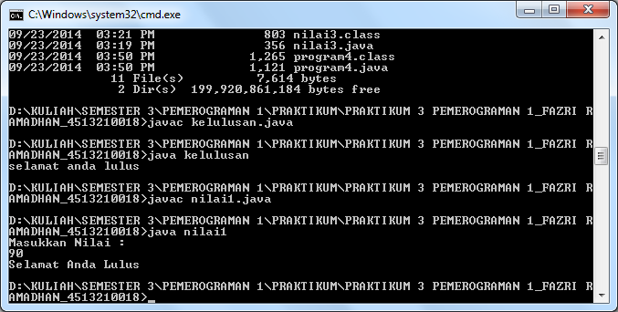

**NILAI 2 :**

**SOURCECODE**

|  |
| --- |
| import java.util.Scanner;  public class nilai2{  public static void main(String[]args){  int nilai;  Scanner masuk = new Scanner(System.in);  System.out.println("Masukkan Nilai :");  nilai = masuk.nextInt();  if(nilai<50){  System.out.println("jelek");  }  else if(nilai==100){  System.out.println("luar biasa");  }  else if(nilai==50){  System.out.println("hampir");  }  else if(nilai>50){  System.out.println("lulus");  }    else if(nilai>100){  System.out.println("salah nilai bro");  }  else  System.out.println("Maaf Anda Tidak Lulus");  }  } |

**PRINTSCREEN**

**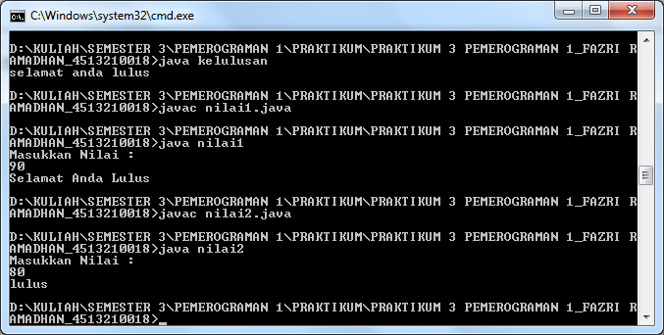**

**NILAI 3 :**

**SOURCECODE**

|  |
| --- |
| import java.util.Scanner;  public class nilai3{  public static void main(String[]args){  int nilai;  Scanner masuk = new Scanner(System.in);  System.out.println("Masukkan Nilai :");  nilai = masuk.nextInt();  //if(nilai<50){  System.out.println("nilai anda "+nilai);  //}  //else  // System.out.println("Maaf Anda Tidak Lulus");  }  } |

**PRINTSCREEN**

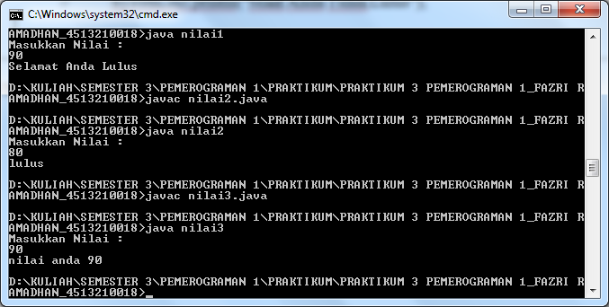

**PROGRAM 4 :**

**SOURCECODE**

|  |
| --- |
| import java.util.Scanner;  public class program4{  public static void main (String[]args){  int pilih;  Scanner input = new Scanner (System.in);  System.out.print ("sehari hari...\n");  System.out.print ("\n1. Makan");  System.out.print ("\n2. Mandi");  System.out.print ("\n3. Tidur");  System.out.print ("\n4. Jalan-jalan");  System.out.print ("\n5. Dota");  System.out.print ("\n6. Pacaran");  System.out.print ("\n7. BERAQZ");  System.out.print ("\n\nMasukkan pilihan anda : ");    pilih = input.nextInt();    switch(pilih){  case 1 :  System.out.println ("Saya suka makan");  break;  case 2 :  System.out.println ("Saya suka Mandi");  break;  case 3 :  System.out.println ("Saya suka Tidur");  break;  case 4 :  System.out.println ("Saya suka Jalan-jalan");  break;  case 5 :  System.out.println ("Saya suka Dota");  break;  case 6 :  System.out.println ("Saya suka Pacaran :')");  break;  case 7 :  System.out.println ("Saya suka BERAQZ");  break;    default : System.out.println ("Hanya sendiri (Ngelanjutin lagu)");  }  }  } |

**PRINTSCREEN**

